Code Generation
The previous options were concerned with representing the tools path across the workpiece as a sequence of points. This section is concerned with transforming that sequence of points into a full G code program. The resulting program can then be saved to the disc for subsequent use.

This conversion from coordinates to gcode is performed using a collection of text Templates.

Templates
Templates are text strings that may contain replaceable symbols. A symbol is represented in the text by the following sequence of characters

......{Binding property} ....

Where property is some property value defined in the Data context of the code generator. When the code instantiator reads a symbol it is replaced by the corresponding property value. As an example the property CurrentPoint is defined in the code generator so that a template such as

X {Binding CurrentPoint.X} Y {CurrentPoint.Y}

Will result in a string value " X 100 Y 50 " when evaluated with the current point being (100,50)

Properties Currently Supported
The properties supported include all the Application settings plus some others. These are
- UseRotary - a flag set true if supporting a rotary table.
- UseAbsolute - a flag set true if absolute positioning required.
- UseSub - a flag set true if each gcode for path is to be generated as a subroutine.
- UseSingleFile - a flag set true if only a single gcode file is to be generated.
- Now - property giving current time and date.
- DP - an integer giving number of decimal places values are rounded to.
- Feedrate - a value giving the machine feed rate.
- CurrentPathIndex - an integer representing the index of the current path.
- PatternName - a string giving the name of the pattern used to produce the current path.
- SubPathName - a string giving the auto generated subroutine / path name.
- PathCount - an integer value giving the number of points in the current path.
- FirstPoint - the first point on the current path.
- CurrentPoint - the point on the current path being considered.
- Gcodes - a table giving the vaues of G codes.
- Mcodes - a table giving the values of M codes.
- SafeHeight - value of cutter height for safe moves.
- CuttingDepth - depth value of cutter when tracing path

G code program layout
G code programs usually follow a typical layout. This layout can be represented by a series of templates that are instantiated as the code generation process proceeds. OTWB represents this layout by the following sequence of templates

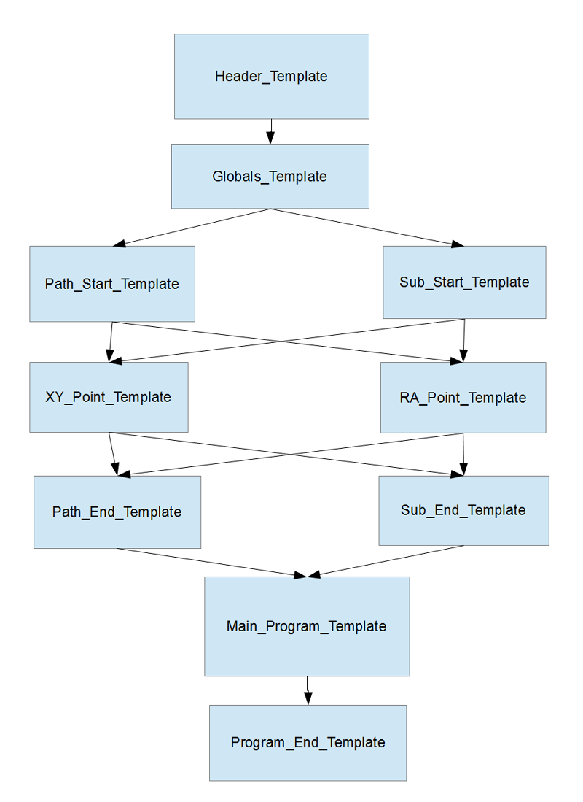
The template sequence starts with the HEADER_TEMPLATE which as its name suggests allows the user to display pertinent information about the program. Following this is the GLOBALS_TEMPLATE where you define your G code constants such as the safe working height or the cutting depth etc.
You can choose to opt for your paths to be generated as straight G code or encapsulated in a subroutine. The subroutine is necessary if you wish to store the path in a seperate file from the main program. So there is a corresponding choice between using the PATH_START_TEMPLATE or the SUB_START_TEMPLATE. I guess that strictly speaking only one template is necessary but for now I have chosen to separate these concerns at present . Both of these templates may include code to initialise matters before visiting each point on the path. Such initialisation code could for instance move the cutter to the safe height then male a rapid moveto the first point on the path and then finally making a linear move to lower the cutter to the current cutting depth.
Both of the two initialising templates mentioned above would be followed by repeated use of the next template which translates the points on the path into G code movements. The generation of the code for the path uses either the XY_POINT_TEMPLATE or the RA_POINT_TEMPLATE and this choice is dependent upon the type of Coordinates being used. Again I think that perhaps only one template is really necessary. The idea was that if you choose to use a rotary table or similar layout such as my rose engine. Then the best coordinates to use are Polar coordinates as they give you directly Radial (distance for tool to move horizontally ) and an Angle (ammount of table rotation required) values. So for this use the RA_POINT_TEMPLATE. Otherwise for a standard mill use the XY_POINT_TEMPLATE.
At the end of the path some cleanup code is required such as moving the cutting tool back to its safe height etc. Either the PATH_END_TEMPLATE or the SUB_END_TEMPLATE should be used for this.

For very simple linear code the next template called the MAIN_PROGRAM_TEMPLATE is not necessary. However if you want to use subroutines and call them from within a loop then this is where you would place that code. Finally the PROGRAM_END_TEMPLATE allows you to add clean up code and terminate the program.
It is obvious from the discussion above that several templates may be superflouous if this is so just leave them empty or set their Include flag to false.

Default Template Values
Each of the templates mentioned above has a simple default value defined by OTWB. However remember that templates can be edited , saved and loaded so that you have the ability to specify numerous template examples. The default values are

HEADER_TEMPLATE

( Gcode Program )
( BY: OTWB )
( ON: {Binding Now} )
( Flags: )
( Rotary : {Binding UseRotary} )
( Absolute : {Binding UseAbsolute} )
( Subroutine : {Binding UseSub} )
( Single File : {Binding UseSingleFile} )
( )
( Machine Settings )
( Feed rate : {Binding Feedrate} )
( Safe height : {Binding Safeheight} )
( Cut depth : {Binding Cuttingdepth} )
( Accuracy : {Binding DP} dp )
( Num Paths : {Binding PathCount} )
(-------------------------------------------)

GLOBALS_TEMPLATE

<_safeheight> = {Binding Safeheight} ( Safe cutter height )
<_cutdepth> = {Binding CuttingDepth} ( Current cutter depth )
<_feedrate> = {Binding Feedrate } ( Feed rate )

PATH_START_TEMPLATE

(PATH {Binding CurrentPathName} )
{Binding Gcodes.Absolute_Moves}
{Binding Gcodes.Rapid_Move} Z {Binding Safeheight}
{Binding Gcodes.Rapid_Move} X {Binding FirstPoint.X} Y {Binding FirstPoint.Y}
{Binding Gcodes.Linear_Move} Z {Binding Cuttingdepth} F {Binding Feedrate}

SUB_START_TEMPLATE

o<{Binding SubPathName}> sub
{Binding Gcodes.Absolute_Moves}
{Binding Gcodes.Rapid_Move} Z {Binding Safeheight}
{Binding Gcodes.Rapid_Move} X {Binding FirstPoint.X} Y {Binding FirstPoint.Y}
{Binding Gcodes.Linear_Move} Z {Binding CuttingDepth} F {Binding Feedrate}

XY_POINT_TEMPLATE

X{Binding CurrentPoint.X} Y{Binding CurrentPoint.Y}

RA_POINT_TEMPLATE

X{Binding CurrentPoint.Radius} C{Binding CurrentPoint.Angle}

PATH_END_TEMPLATE

{Binding Gcodes.Rapid_Move} Z {Binding Safeheight}
( END PATH {Binding CurrentPathName} )

SUB_END_TEMPLATE

{Binding Gcodes.Rapid_Move} Z {Binding Safeheight}
o<{Binding SubPathName}> endsub

MAIN_PROGRAM_TEMPLATE

{Binding Gcodes.Rapid_Move} X{Binding FirstPoint.X} Y{Binding FirstPoint.Y} F{Binding Feedrate}
o<{Binding SubPathName}> call

PROGRAM_END_TEMPLATE

{Binding Mcodes.End_of_Program}
( ****** End of Program ****** )

Redundancies
It is becomming apparent to me that several of the binding properties I have included such as Feedrate and Safeheight could just be included as textual values in the GLOBALS_TEMPLATE for example

<_safeheight> = 5 ( Safe cutter height )
<_cutdepth> = -1 ( Current cutter depth )
<_feedrate> = 100 ( Feed rate )

So I am currently undecided about keeping them as bindings.

Simple Example
The simplest program is just be a list of gcode movements one for each point on the tool path. So for example if a path comprised of just a few points say

(0,0) →(0,10)→(10,10)→(0,10)→(0,0)

Then a very simple gcode program would have one line of g code to move from point to point

[1] g90 ( use absolute positioning )
[2] g0 Z 5 ( rapid move to a safe height )
[3] g0 X0 Y0 ( rapid move to first point )
[4] g1 Z -1 F 20 ( linear move to cutting depth )
[5] g1 X0 Y10 ( linear move to second point )
[6] g1 X10 Y10 ( linear move to third point )
[7] g1 X0 Y10 ( linear move to fourth point )
[8] g1 X0 Y0 ( linear move back to first point )
[9] g0 Z 5 ( rapid move up to safe height )
[10] M2 ( end of program )

Note that there are some extra codes we have to include before we move along the path.
- The first line tells the controller that we are using absolute positions.
- The second line is included to raise the cutter to a safe position so that when we move to the first point on the path we do not hit anything.
- The third line rapidly moves to the first point on the path.
- The fourth line then feeds the cutter down to its cutting depth. Notice that with a linear move we have to specify a feed rate.
Lines 5 through 8 will move the cutter along the required path. Notice that we do not need to include a Z value again unless we want the cutting depth to change. Line 9 moves the cutter back to the safe height and line 10 stops the program.

A quick look should be sufficient to convince you that all paths no matter how many points fall into these three stages
- Initialise and move to the first point
- Loop through all the points on the path.
- Final cleanup phase

To cover these stages the user only has to define these templates
- PATH_START_TEMPLATE
- XY_POINT_TEMPLATE
- PATH_END_TEMPLATE
- PROGRAM_END_TEMPLATE

which in this simple case are covered by the default template values anyway. The only thing to do would be to ensure that the MAIN_PROGRAM_TEMPLATE was empty as it is unnecessary. Plus also there would be a Header which I have not shown.

A real example Using Subroutines
To opt to use subroutines set the UseSub flag on. The name of the subroutine will be automatically generated using the pattern name and the path index. So for Bazely pattern 235 which has one path the subroutine name would be bazely#235_0 . A subroutine is never executed until it is called so you need to make a call to this sub. This is done by the default MAIN_PROGRAM_TEMPLATE
If you start OTWB, go to the Bazely page and choose pattern 235.
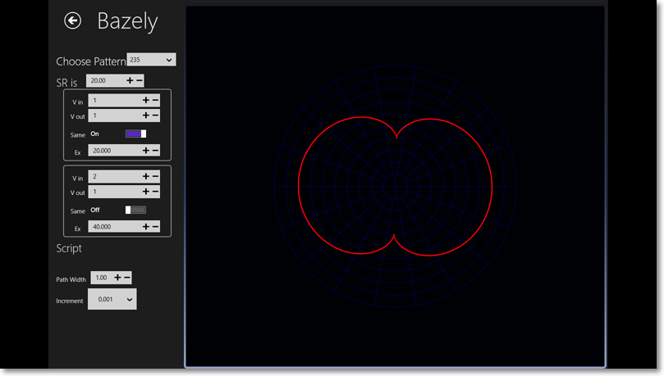
Then go to the gode generation page. Make sure that in the settings the Use Subroutine and Single File switches are on as in the image below
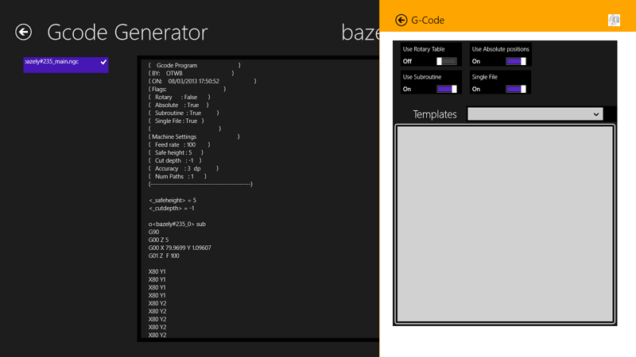

Then the code generated will be as in the image above. Because there are 6284 points on this path I have cut out most of them from the listing below which was created when the code was saved.

